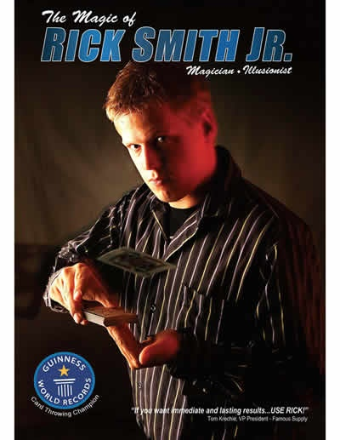
McDowell Elementary
Family Magic Night
Friday, February 9th at
Hudson Middle School, 77 N Oviatt Street
Tickets: $3 per person
Doors open at 6:15 pm
Show starts at 6:30 pm

Presented by McDowell PTO
Bring the family out to enjoy a Rick Smith Jr. magic show! He has appeared on Ellen, America’s Got Talent and The Tonight Show with Jay Leno. It will be an awesome night!
Please learn more about him by visiting his website www.ricksmithjr.com

Questions? Contact Julie Susz at juliesusz@roadrunner.com
If school is closed due to inclement weather, this event will be cancelled and rescheduled for the spring.
--------------------------------------------------------------------------
Please return this form by Wednesday, February 7th

Student’s Name________________________________________________________________________
# attending_______________x$3=__________________
I give the Hudson PTO the right to use photographs or video footage of my child (children) from PTO-sponsored activities. This includes usage in print, broadcast, web, and organization publications.
Parent Signature and Date____________________________________________
Please make checks payable to Hudson PTO

